These product label-images can be printed, cut, and applied (with clear tape) to your Spray Bottles & Containers to label and identify: “TRULYGREEN” Organic Cleaner! (For your handy reference & use!)

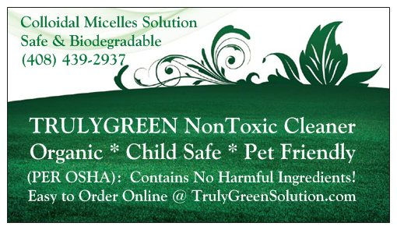
Safer: Per OSHA standards 24 CFR 1910.199 App. A. – Contains
No hazardous chemicals or ingredients.

Safer: Per OSHA standards 24 CFR 1910.199 App. A. – Contains
No hazardous chemicals or ingredients.

